Download And Install Spoon

1. Download ZIP file

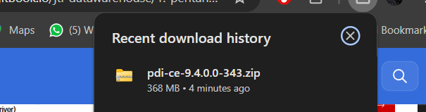

1. Open spoon.bat on file data -integration

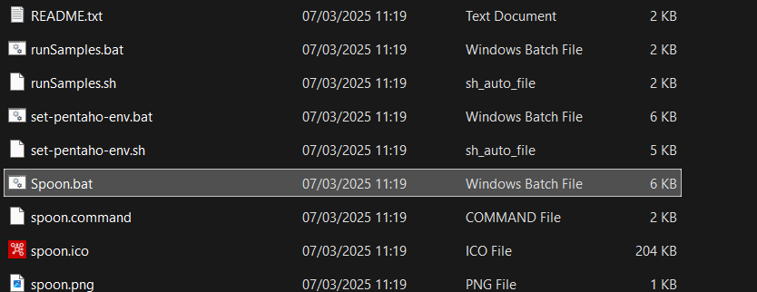

1. Shown the hitachi system

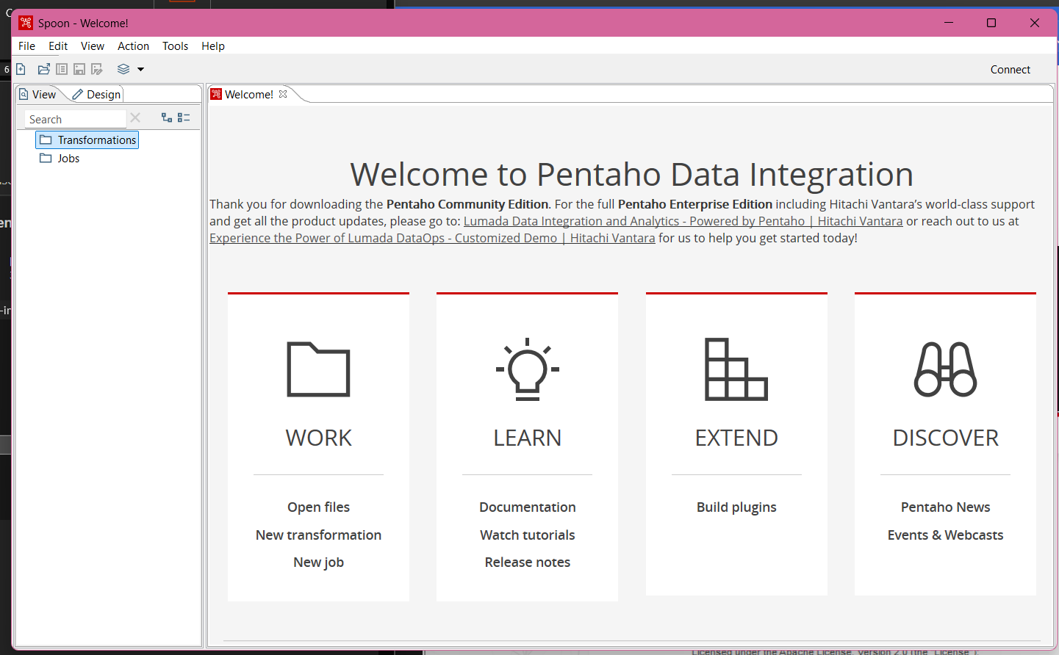

1. Make easier to run the spoon.bat Click on right on spoon.bat and move to desktop



1. Chosse properties and the icon

